**Project Proposal**: Meat Shop Management System

**Team Leader**: David Lance Aguinaldo

**Members**: Reinhold Lucana

Mark Lester Raquel

**Background of the Study**

Noemi Alvarez is selling meat products in her own shop named Noemi’s Meat Shop located at Kamuning, Quezon City. In this shop, they encounter human error when it comes to inserting, and updating different meat quantities in the store’s inventory because they use traditional log book.

**Statement of the Problem**

It’s tedious, messy, and hard to manage an inventory in business by doing manual listing. The reason why we developed this program is that the manual listing method of the business’s inventory system is a tedious work.

**General Objectives**

Eliminate human error, by implementing a computerized version of the quantity and price method. Unlike the usual handwritten method which sometimes be affected by people with poor eyesight and cases like dyslexia and to provide a summary of the prices and compute total charge and change for transactions.

**Specific Objectives**

• To insert products to the inventory.

• To update product details.

• To delete unnecessary entries.

• To record / organize transactions.

**ER Diagram**

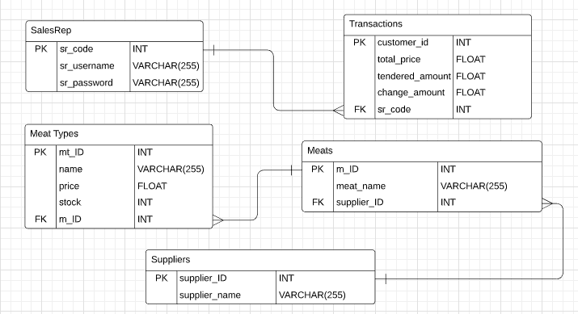

**Group 8:**

Aguinaldo, David Lance.

Lucana, Reinhold

Raquel, Mark